2 TABLE OF CONTENTS
Wood Badge and Scout Songs
Back to Gilwell 6
Weather Rock-A 7
Wood Badge Family 8
I’ve Been Listening Here at Wood Badge 8 That’s Why We’re in Cub Scouting 9
Quartermaster Store 10
Wood Badge Patrol Song 11
Cub Scout Spirit 12
SuperBalooandCubScoutCamper 13
Pizza MAN 14
Trusty Johnny 15
Ticket to Write 15
When the Scouts Go Marching In 16
Hiking Song 16
Wood Badge Bunch 17
If I Were Not a Boy Scout 18
Gee Mom I Want to Go Home 19
Wood Badge Favorite Things 20
Call A Scout 21
Follow Me Boys 22 Commercial Mix Up 23
Taps 23
Scout Vespers / Scout Wetspers 24
67
The Outdoor Code
As an American, I will do my best to:
Be clean in my outdoor manners,
Be careful with fire,
Be considerate in the outdoors, and
Be conservation minded


- Plan Ahead and Prepare
- Travel and Camp on Durable Surfaces
- Dispose of Waste Properly
- Leave What You Find
- Minimize Campfire Impacts
- Respect Wildlife
- Be Considerate of Others
Staff Favorites

Alice – Jax Phelps, Samantha Maynard
Baby Shark – Denice Marco
Back to Gilwell – Adam Blalock
Blue Jay – Tyler Wright
Boom Chicka Boom – Amber Palmier
Bug Juice – Kevin Ray
Columbo – Aide Wright
Foggy – Mr. Wright, Doc Brown, Kira Willams
Ghost Chickens – Tyler Gomez, David Rice, Dave Luthin, Rhonda Byrd
God Bless My Underwear – Chris Gonzalez, Anthony East
Jaws – Julie Decker
Pizza Man – Watson Rice
Purple Stew – Lena Pelham
Quarter Master Store – Shirley Zange
School House Rock Preamble – Walden Knott
Scout Vespers – Wanda Elleberger

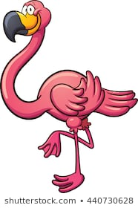
4 Fun Songs (cont’d)
My Turtle 41
John Jacob Jingleheimer Shmidt 41
Do Your Ears Hang Low 42
Chicken Song 42
Scouts Don’t Wear No Socks 43
1492-Columbo 44-45
Eats 45 Alice 46
The Coming of the Frogs 47
BINGO 48
Pink Pajamas 48 Wood Badge Bunch 49 Boom chicka boom 50 Blue Jay Died of the Whooping Cough 51
God Bless My Underwear 51
Campfire / Scout’s Own Service Songs
This Land is Your Land 52 Battle Hymn of the Republic 53
Pass It On 54
If I Had a Hammer 55
It’s In Every One of Us 56
Kum Ba Yah 57
This is the Day That the Lord has Made 57
Amazing Grace 58 Hey Ho 59
We’re Camping in the Rain 65
[tune: Singing in the Rain]

We’re singing in the rain.
We’re camping in the rain,
Who needs sun to have fun.
We are outside again.
There’s so much to do
There’s no time to be blue.
‘Cause we’re singing and camping in the rain.

We’re hiking around
With mud on the ground
What a glorious feeling
When we’re dry again.
We’re not getting down
We’re the best Boy Scouts in town
‘Cause we are singing and camping in the rain.



6 Back To Gilwell
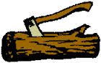
I used to be a Beaver, a good ‘ol Beaver too
But now I’ve finished Beavering
I don’t know what to do
I’m growing old and feeble
And I can Beaver no more
So I’m going to work my ticket if I can
[Chorus:] Back to Gilwell, happy land
I’m going to work my ticket if I can!
Bobwhite—Bobwhiting—Bobwhite no more
Eagle—Eagling—Eagle no more
Fox—Foxing—Fox no more
Owl—Owling—Owl no more
Bear—Bearing—Bear No More
Buffalo—Buffaloing—Buff no more
Antelope—Anteloping—’Lope no more
Venturer—Venturing—Venture no more*
Staffer—Staffing—Staff no more
[* Venturers when present]

God Our Father 63
[Tune: Are You Sleeping]
God Our Father, God Our Father,
Once again, once again,
We would ask thy blessing,
We would ask thy blessing,
Amen, Amen.
Edelweiss Grace
Bless our friend, bless our food, come oh Lord and be with us. May our words, glow with peace; may your lo-ve surround us. Friendship and love may it bloom and grow; bloom and grow forever. Bless our friends, bless our food. Come, oh, Lord and be with us.
Scout Grace All good things come from you, O God. You have given us our food, our friends and all our blessings. Help us to have one more thing, a grateful heart. Amen

Philmont Grace 61
For food, for raiment, for life, for opportunity
For friendship and fellowship
We thank thee, O Lord Amen
Summit Grace
For this time and this place
For your goodness and grace
For each friend we embrace,
We thank thee O Lord, Amen
Sea Base Grace
Bless the creatures of the sea
Bless this person I call me
Bless these Keys you made so grand
Bless the sun that warms this land
Bless the fellowship we feel
As we gather for this meal
Amen
8 Wood Badge Family
[Tune: Addam’s Family theme song]

[Chorus:]
Da-da-da-da (snap, snap), Da-da-da-da (snap, snap)
Da-da-da-da, da-da-da-da, Da-da-da-da (snap, snap)
We’re sleepy and we’re kooky, delirious and goofy
Our underarms are ooky, the Wood Badge family
[Chorus]
So with our Wood Badge hats on
The Gilwell song will go on
Our tickets we will work on, the Wood Badge family.
[Chorus]
I’ve Been Listening Here At Wood Badge
[Tune: I've Been Working On The Railroad]
I've been listening here at Wood Badge
All the live long day
I've been listening here at Wood Badge
Just to hear the Kudu play
Can't you hear the Kudu blowing
Rise up so early in the morn
Can't you hear the leader shouting
Woodman blow your horn

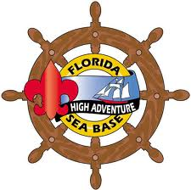
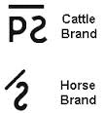
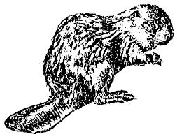
Hey Ho 59
[Sung in a three-part round]

Hey ho, nobody home
Meat nor drink nor money have I none
Yet I will be merry
Superman Blessing
Thank you God for giving us food (arms up to right)
Thank you God for giving us food (arms up to left)
For the friends we meet (arms up to right)
And the food we eat (arms up to left)
Thank you God (arms straight up)
Amen (arms down)

10 Wood Badge Quartermaster Song
There are beavers, beavers, beavers
Wielding rusty cleavers
At the store, at the store
There are beavers, beavers, beavers
Wielding rusty cleavers
At the Quartermaster’s store
[Chorus:] My eyes are dim; I cannot see
I have not got my specks with me
Bob, bobwhites, wearing wrestling tights….
Eagles, eagles, eagles, chasing little beagles….
Foxes, foxes, foxes, wrapped in little boxes….
Owls, owls, owls, eating paper towels….
Bears, bears, bears with curlers in their hair….
Buff—a—loes, with mud between their toes….
Ant—e—lopes, eating cantaloupes….
Staffers, staffers, staffers, hanging from the
rafters….

12 Cub Scout Spirit
[Tune: I’ve got the Joy]
*Point to each body part as you sing*

I've got that Cub Scout Spirit up in my head
Up in my head, Up in my head
I've got that Cub Scout Spirit up in my head
Up in my head to stay
I've got that Cub Scout Spirit deep in my heart ….
I've got that Cub Scout Spirit down in my feet ….
I've got that Cub Scout Spirit all over me…..
I've got that Cub Scout Spirit up in my head,
Deep in my heart, down in my feet
I’ve got the Cub Scout Spirit all over me
All over me to stay

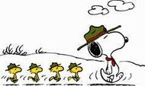

Kum Ba Yah 57
Kum ba yah, my lord, Kum ba yah
Kum ba yah, my lord, Kum ba yah
Kum ba yah, my lord, Kum ba yah
O Lord, Kum ba yah
Someone's singing, Lord, Kum ba yah….
Someone's laughing, Lord, Kum ba yah….
Someone's crying, Lord, Kum ba yah…..
Someone's praying, Lord, Kum ba yah…
Come by here my Lord, come by here…
This is the Day That the Lord Had Made
This is the day, this is the day that the Lord has made, that the Lord has made We will rejoice , we will rejoice and be glad in it, and be glad in it. This is the day that the Lord has made, we will rejoice and be glad in it. This is the day, this is the day that the Lord has made.


14 Pizza Man

This is a repeat after me song

Hey, hey, bo diddly bop
I’ve got to get back to my block.
With a Pizza in my hand
I’m gonna be a pizza MAN!

With these wires in my hand
I’m gonna be an ElectricIAN!
Pizza MAN!

With a basketball in my hand
I’m gonna be like Michael JordAN!
ElectricIAN!
Pizza MAN!

With my car keys in my hand
I’m gonna drive a mini VAN!
Michael JordAN!
ElectricIAN!
Pizza MAN!

If I Had a Hammer 55
If I had a hammer, I’d hammer in the morning
I’d hammer in the evening, all over this land
I’d hammer out danger, I’d hammer out warning
I’d hammer out love between my brothers and my
sisters, all over this land, oooooh
If I had a bell, I’d ring it in the morning
I’d ring it in the evening, all over this land
I’d ring out danger, I’d ring out warning
I’d ring out love between my brothers and my sisters
All over this land, oooooh
If I had a song to sing, I’d sing it in the morning
I’d sing it in the evening, all over this land
I’d sing out danger, I’d sing out warning
I’d sing out love between my brothers and my sisters
All over this land, oooooh
Well I’ve got a hammer, and I’ve got a bell
And I’ve got a song to sing, all over this land
It’s a hammer of justice, it’s a bell of freedom
It’s a song about love between my brothers and my
sisters, All over this land
16 When the Scouts Go Marching In
Oh when the Scouts, go marching in
When the Scouts go marching in
Oh Lord I want to be in that number
When the Scouts go marching in
2. Oh when the Scouts, advance in rank
3. Oh when the Web’los, become Boy Scouts
4. Oh when Boy Scouts, do service work
5. Oh when Ven-turers, teach skills and crafts
6. Oh when the Leaders, Lead the Way
Hiking
[Tune: Caisson Song]

O-ver hill, o-ver dale
We will hit the green-wood trail
As the Boy Scouts, go hiking, along
In and out, all around, you will never see us frown
As the Boy Scouts, go hiking, along
And it’s hi hi hee, the BSA for me
Shout out our name and shout it strong
Where’er we go, we will always know
That the Boy Scouts, go hiking, along

Battle Hymn of the Republic 53
Mine eyes have seen the glory of the coming of the Lord
He is trampling out the vintage
Where the grapes of wrath are stored
He hath loosed the fateful lightning
Of His terrible swift sword, His truth is marching on
[Chorus:]
Glory glory hallelujah, glory, glory, hallelujah,
Glory glory hallelujah, His truth is marching on
I have seen Him in the watch-fires
of a hundred circling camps
They have builded Him an altar
In the evening dews and damps
I can read His righteous sentence by the dim and
flaring lamps, His day is marching on. [Chorus]
In the beauty of the lilies, Christ was born across the sea
With a glory in His bosom that transfigures you and me
As He died to make men holy
Let us die to make men free
While God is marching on [Chorus]

Blue Jay 51
[A repeat after me song]
Chorus Way down yonder not so far off. A blue jay died of the whooping cough. Well he whooped and he whooped and he whooped all day He whooped his head and tail away
Second verse, same as the first
A little bit louder and a little bit worse [Chorus] Third verse, same as the first A whole lot louder and a whole lot worse [Chorus]
God Bless My Underwear
[Tune: God Bless America]
God bless my underwear, my only pair
Stand beside them, and guide them
Through the rips, through the holes,
through the tears
From the washer, to the dryer,
to my backpack, to my rear
God bless my underwear, my only pair
God bless my underwear, my only pair

God Bless My Underwear
[Tune: God Bless America]

God bless my underwear, my only pair
Stand beside them, and guide them
Through the rips, through the holes,
through the tears
From the washer, to the dryer,
to my backpack, to my rear
God bless my underwear, my only pair
God bless my underwear, my only pair

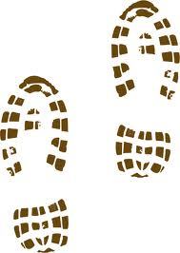
18 If I Were Not a Boy Scout

[Chorus:]

I’m so glad that I’m a Boy Scout, that is what I truly like to be, cause if I were not a Boy Scout, a ......
A bird watcher I'd be
Hark a lark, flying through the park, SPLAT! [Chorus]
A plumber I would be
Flush it, plunge it, look out below! [Chorus]
A carpenter I'd be
Two by four, nail it to the floor! [Chorus]
A ice cream maker I'd be
Ooshy gooshy, ooshy gooshy, good ice cream! [Chorus]
A camp chef I would be
Mix it, bake it; pass the Tums-BURP! [Chorus]
A laundry worker I would be
Starchy here, starchy there, starchy in your underwear!
[Chorus]
A Scoutmaster I would be
Do this, do that, I'm gonna take a nap

Wood Badge Bunch 49
[Tune: Brady Bunch Theme Song]

Here’s the story of a man named Powell who trained some men very long ago. On Gilwell field , in jolly old England his wisdom he bestowed.
Here’s the story of 48 scouters a great group of guys and gals who with their awesome instructors began their quest as well.
Till one day all their visions and goals were approved right after lunch. Through lots of hard work and laughter that’s the way we all became the Wood Badge Bunch. The Wood Badge Bunch, The Wood Badge Bunch. That’s the way we all became the Wood Badge bunch.

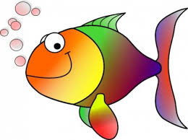

20 Wood Badge Favorite Things
[Tune: These are a few of my favorite things]
Raindrops on canvas and blisters on feet
Gill-ill-well park where wood badgers meet
Aluminum camp gear with all of its dings
These are a few of my favorite things!
[Chorus:]
When the tick bites, when the sweat stings
When I’ve feeling sad
I simply remember my favorite things
and then I don’t feel so bad.
Soot covered ovens and warm apple strudels Staff in the field, have lost all of their noodles. Time honored values and songs that we sing. These are a few of my favorite things!
[Chorus]
Boy Scouts in field dress with merit badge sashes
Sturdy camp gadgets all tied up with lashes
Silver haired scoutmasters, hiking by springs These are a few of my favorite things!
[Chorus]

The Coming of the Frogs 47
[Tune: Battle Hymn of the Republic]
Mine eyes have seen the horror of
The coming of the frogs
They’re sneaking thru the swamps
And they are lurking in the logs
You can hear their mournful croaking
Through the early morning fog
The frogs keep hopping on
[Chorus:]
Ribbet, ribbet, ribbet, croak, croak
Ribbet, ribbet, ribbet, croak, croak
Ribbet, ribbet, ribbet, croak, croak
The frogs keep hopping on
I used to like the bullfrogs
Like to feel their slimy skin
Liked to put them in my teacher’s desk
And take them home again
Now they're knocking at the front door
And they’re starting to come in
The frogs keep hopping on [Chorus]

22 Follow Me Boys
[Robert B. and Richard M. Sherman, from the
Walt Disney film “Follow Me Boys”]
[Chorus:] Follow me boys, follow me
When you think you’re really beat
That’s the time to lift your feet
And follow me boys, follow me
Pick them up, put them down, and follow me
There’s a job to do, there’s a fight to win
Follow me boys, follow me
And it won’t be done till we all pitch in
Lift your chin with a grin and follow me! [Chorus]
It’s a long, long time, but we’ve got the will
Follow me boys, follow me
When we reach the top, then it’s all downhill
Till your drop, don’t stop, and follow me! [Chorus]
Though the journey’s end is beyond our sight
Follow me boys, follow me
If we do our best then we’ve done all right
Pack your load, hit the road, and follow me! [Chorus]

1492 – Columbo (cont’d) 45
The first mate, the first mate, yes he was a biggun’
He fought and killed an octopus
And used its arms for riggin [Chorus]
The captain, the captain, yes he was a sailin’
He guided us around the world
And home without a failin’ [Chorus]
Eats Song
[Tune: Hail, Hail, the Gang’s All Here]
Soup, soup, we all want soup
Tip your bowl and drain it, let your whiskers strain it
Hark, hark, the funny noise, listen to the gurgling boys
Meat, meat, bring on the meat
Fresh and juicy cow meat, ham and pickled pig’s feet
Lamb chops and pork chops too
Any kind of meat will do
Fish, fish, we must have fish
We don’t want it bony, nor a little phony
Fresh fish, we won’t eat stale
Any kind of fish but whale

.

24 Scout Vespers
[Tune: O Tannenbaum]
Softly falls the light of day
As our campfire fades away
Silently each Cub Scout asks
“Have I done my daily task”
For my country done my best
Prayed to God before I rest
Helped a friend along the way
Have I done my best today?
Scout Wetspers
[Tune: O Tannenbaum]
Softly falls the rain today
As our campfire floats away
Silently each Scout should ask
“Did I bring my scuba mask?”
Have I tied my tent flaps down
Learned to swim so I won’t drown
Have I done and will I try
Everything to keep my dry

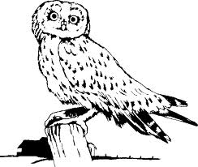

26 Alabama State Song
Alabama, Alabama, we will aye be true to thee
From thy Southern shores where groweth
By the sea thy orange tree
To thy Northern vale where floweth
Deep and blue thy Tennessee
Alabama, Alabama, we will aye be true to thee
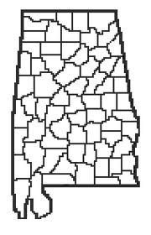

This Is My Country

This is my country, land of my birth
This is my country, grandest on earth
I pledge thee my allegiance
America, the bold
For this is my country
To have and to hold

Cub Scouts Don’t Wear No Socks 43
[
Cub Scouts don’t wear no socks. Saw them when they took them off. Threw them in the washing machine. That’s how he laundry all turned green.
Cub Scouts don’t wear no socks. Saw them when they took them off. Threw them in the garbage can. Killed three rats and the garbage man.
Cub Scouts don’t wear no socks. Saw them when they took them off. Threw them up into the air. That’s why the birds need Medicare.
Cub Scouts don’t wear no socks. Saw them when they took them off.
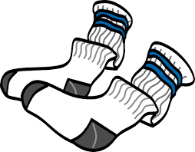

My Turtle 41
[Tune: On Top of Old Smokey]
My turtle is awesome, mine’s better than yours
My turtle is awesome, he can open the doors
My turtle is olive, your turtle’s lime green
My turtle’s a Boy Scout, he can dig a latrine
My turtle swims sideways, your turtle just sinks
My turtle can back stroke, your turtle just stinks
My turtle’s a fun guy, he likes to stand on his head
Your turtle doesn’t do much
‘Cause your turtle is dead

John Jacob Jingleheimer Schmitt
John Jacob Jingleheimer Schmidt
His name is my name too
Whenever we go out, the people always shout
John Jacob Jingleheimer Schmidt
Da da da da da da da

.

28 God Bless America
God bless America, land that I love
Stand beside her—and guide her
Through the night with the light from above
From the mountains, to the prairies
To the oceans, white with foam
God bless America, my home sweet home
God bless America, my home sweet home
Schoolhouse Rock - Preamble

We the people of the United States,
In order to form a more perfect union,
Establish justice, insure domestic tranquility,
Provide for the common defense,
Promote the general welfare and
Secure the blessings of liberty
To ourselves and our posterity
Do ordain and establish this Constitution for
The United States of America!

30 The Ants Go Marching
The ants go marching one by one, hurrah, hurrah
The ants go marching one by one, hurrah, hurrah
The ants go marching one by one
The little one stops to suck his thumb
And they all go marching down, to the ground
To get out, of the rain, Boom Boom Boom….
Two by two…………....Tie his shoe
Three by three……....Climb a tree
Four by four……….....Shut the door
Five by five…………….Take a dive
Six by six…………….....Pick up sticks
Seven by seven……….Pray to heaven
Eight by eight………...Open the gate
Nine by nine…………..Check the time
Ten by ten………………Say “THE END” (stop here)

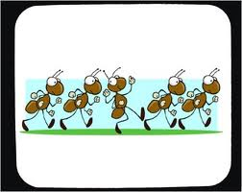
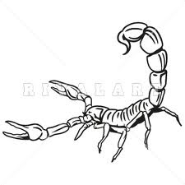
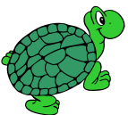
Itsy Bitsy Scorpion 39
[Tune: Itsy Bitsy Spider]

The itsy bitsy scorpion crawled up upon my shirt.
I smashed him with my hand and threw him in the dirt,
When he stopped a squirming I put him in my stew,
'Cause itsy bitsy scorpions taste good to me and you!
An Annoying Song [tune: Battle Hymn of the Republic]
I know a song that gets on everybody’s nerves. I know a song that gets on everybody’s nerves. I know a song that gets on everybody nerves and this is how it goes….
(repeat at least three more times)


.

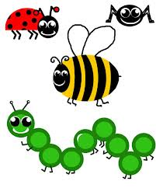
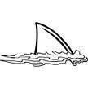
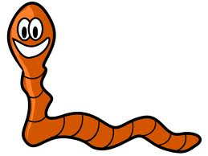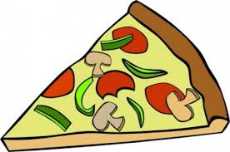
Worm Song 35
Nobody likes me, everybody hates me
Think I’ll go eat worms
BIG FAT juicy ones, little tiny skinny ones
Just so they wiggle and squirm
Bite their heads off, suck their guts out
Throw their skins away
Nobody knows how I can eat just worms
Three times a day

Pizza Song
Everybody likes me, nobody hates me
Think I’ll go eat pizza
Big fat anchovies, little tiny pepperonis
Just cause they taste good
Bite those anchovies, eat those pepperonis
Throw the crust away
Nobody knows how I can just eat PIZZA
Ten times a day

.

Bug Juice 37
[Tune: On Top of Old Smoky]
At camp with the Boy Scouts
They gave us a drink
We thought it was Kool-Aid
Because it was pink
But the thing that they told us
Would’ve grossed out a moose
For that great tasting pink drink
Was really bug juice
It looked fresh and fruity
Like tasty Kool-Aid
But the bugs that were in it
Were murdered by Raid!
We drank it by gallons
We drank it by tons
And early next morning
We all had the runs
Next time you drink bug juice
And a fly drives you mad
He’s just getting even
Cause you swallowed his dad!

34 Baby Shark
(shark mouth with hands connected at wrist)
Baby shark, Doh-doh, doh, doh
Baby shark, Doh-doh, doh, doh
Baby shark, Doh-doh, doh, doh
Baby shark

Momma shark….(forearms connected at elbows)
Daddy shark….(shark mouth with full arms)
Grandpa shark….(use fists to look like no teeth)
Swimmer dude….(swimming crawl motion with arms)
Hungry shark….(hand on top of head like shark fin,
other hand rubbing stomach)
Swam away….(backstroke)
Swam too slow ….(frantic backstroke)
Lost a leg….(hop on one leg)
Happy shark….….(hand on top of head like shark fin,
other hand rubbing stomach)
That's the end….(point to your backside)

32 Ghost Chickens in the Sky
A chicken farmer went out, one dark and dreary day
He rested by the coop, as he went along his way
All at once a rotten egg, hit him in the eye
It was a sight he dreaded, Ghost Chickens in the sky
[Chorus:] Bok-Bok-Bok-Bok, Bok-Bok-Bok-Bok,
Ghost Chickens in the sky.
The farmer had raised chickens since he was twenty-four
Working for the Colonel for thirty years or more
Killing all those chickens, and sending them to fry
Now they want revenge, ghost chickens in the sky
[Chorus]
Their feet were black and shiny, their eyes were burning red
They had no meat or feathers, these chickens all were dead
They picked the farmer up and he died by the claw
They cooked him extra crispy and served him with cole slaw
[Chorus]

